User Testing Notes

General points across the app.
- Print/pdf option should be present on all output pages
- Fix formatting errors with the download to pdf button on the Governance Framework
- Pdf download button sizes are inconsistent. Make them the same size everywhere
- When printing something, the admin view banner is included in the printed screen at bottom when done via browser.
- Admin panel blocks buttons on bottom left of screen in current placement
- Top buttons missing or unaligned borders throughout each phase
- Multiple module steps have the same icon (circled dot) (1.3, 2.2, 2.4)
- In sections that generate charts and graphs as you fill out fields, it awkwardly prevents you from clicking into one field from another. This is caused by it updating the graphs/charts when you unfocus the input box.
- Buttons required for completion mid-section should be a little brighter/more obvious
- Organize phase. Ownership and structure step: RACI matrix seems to have a maximum of 9 people before the chart stops adding more
- Organize phase. Org Readiness output. Print to pdf has awful formatting for the "Readiness" bar at the bottom of the page, it just becomes an entire page of blue for me.

Two more notes:

1. On the profile page, there is some text at the top that is invisible in light mode:
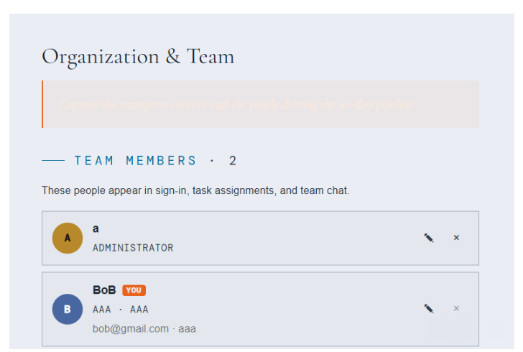
Change text color to black when in light mode.
2. The symbols for each step on the progress bar on the Phase overview pages do not correspond with the symbols on the sidebar. Please use the sidebar symbols here as well.
